TABLE OF CONTENTS
SUBJECT PAGE NO.

Details
Definition of Terms...................................….............….2
Project Name….....................................….….................2
Project Description.............................…...….................2
Scope...………………..............................…...….................2
Limitations …........................................….….................3
Interfaces.............................................…..…................. 3
Functional Capabilities.....................….....…..................3
Screen Flow.........................................…….......…...........9
Data Flow Diagram...........................…......................….13
Performance Levels …......................…....................…...13
Security Features..........................…........................………...13
User Roles....................................……......................………...14
Appendices
Appendix A: Project Work Plan
Appendix B: Project Risk Inventory
Appendix C: Project Estimating Worksheet

Sign-Off.................................................................…........15

Details

Definition of Terms
(This section refers to words and terms used that need to be defined to facilitate understanding and ensure proper interpretation of the document.)
Terms | Description
FPMS
AMS
Fields | Data entry in the forms and reports. For examples text box, drop down list, header, etc.
BDOLF | BDO Leasing and Finance
BDORI | BDO Rental Inc.

Project Name:
  - BDOLF FPMS/AMS Report Extraction.
    - BDOLF LAD
    - BDOLF LPC
    - BDOLF Accounting

Project Description
  - Objectives
    - To extract fields from FPMS/AMS Reports for properly archiving allowing to be used of BDOLF LAD, BDOLF LPC and BDOLF Accounting for future references from the initial used of the system.
    - To store the archived data to network path and to be accessed by BDOLF LAD, BDOLF LPC and BDOLF Accounting: ____________________________________.

Scope
  - BDOLF LAD, BDOLF LPC and BDOLF Accounting requirements for the extraction.
    - BDOLF LAD data should be extracted from FPMS/Collateral Maintenance Form.
    - BDOLF LPC and BDOLF Accounting data should be extracted from FPMS and AMS report with the following modules.
      - Adjustment Module
      - Disbursement Module
      - Payment Module
      - Schedule of Subledger
      - Schedule of Check Issuance
    - BDOLF LPC also needed the details to be extracted from
      - Account Payment History report
      - FPMS Transaction Worksheet report
      - Client List of Account report

Limitations
  - Files can be be extracted from a window form designed in Microsoft Visual Basic 6.0.
  - All extracted will be on TSV (Tab Seperated Value) Files format that can be open in LibreOffice Calc or Microsoft Windows Excel .xls.

Interfaces.
(Enumerate and describe the interface requirements under each of the following systems. Minimum information should include the following:(1) type of flow(ie., input or output to the interfacing system, or both), (2) type of interface (e.g. batch SFTP, web service, database etc.), (3) data to be interfaced (e.g. GL entries, transaction amount, client names. etc.) Put n.a. if no interface is required.)
  - ICBS – Not applicable.
  - IST – Not applicable.
  - DIDR – Not applicable.

  - SAS-AMLA – Not applicable.

  - Other – Not applicable.

Functional Capabilities
  - The following details are the requirements of BDOLF LAD, LPC and Accounting prior to the decommissioning of FPMS and AMS that must be properly archived allowing to be accessed for future references.
    - BDOLF LAD.
      - The following details from FPMS/ Collateral Form are the requirements to be extracted.
        - Account No. The mandatory account number field of client formatted in number.
        - Client Code. The mandatory Client Code field formatted in number.
        - Account Officer. The transaction initial name of the account officer.
        - Client Name. The client or business name of the transaction.
        - Asset Classification. The transaction categorized in asset classification.
        - Motor Engine / BDOLF Sticker. The physical registered motor engine of the vehicle.
        - Chassis Number. The physical registered Chassis number of the vehicle
        - Maturity Date (Expiry Date). The expiry date of the transaction.
        - Remarks. Comments by the account officer for the transactions as reference.
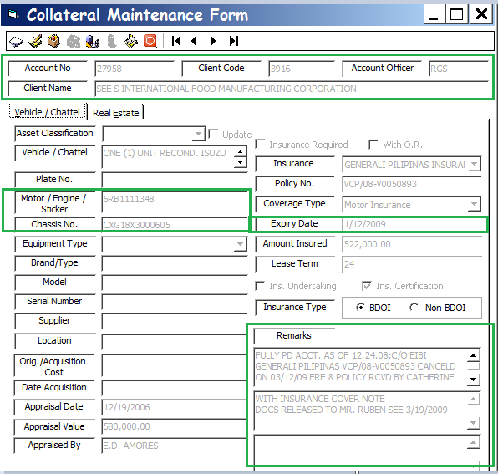

Extracted Data in Excel/Calc Format
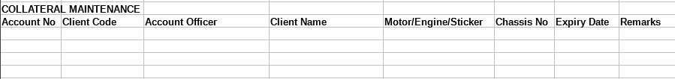

    - BDOLF LPC and BDOLF Accounting
      - Adjustment Module. The following details from FPMS/ AMS report system are the requirements to be extracted.
        - Date. The transaction date. Formatted in mm/dd/yyyy.
        - Details. Important information about the Adjustment transaction.
        - Comment. An explanation about the behavior in textual format of the transaction.
        - Account Title. A narrative description of the account title of the transaction.
        - GL Codes. A general ledger coding or symbolic arrangement of account title.
        - Debit. An accounting entry acknowledging sums that are owing. Formatted in currency.
        - Credit. An accounting entry acknowledging income or capital items. Formatted in currency.
Adjustments Module

Extracted Data in Excel/Calc Format

      - Disbursement Module. The following details from FPMS/ AMS report system are the requirements to be extracted.
        - Date, transaction date of the transaction formatted in mm/dd/yyyy, example 12/01/2017
        - Check Series, column formatted in number.
        - Release To, the client name column formatted in string.
        - Comment, formatted in string containing the remarks regarding to transaction.
        - Account Title. A narrative description of the account title of the transaction.
        - Debit. An accounting entry acknowledging sums that are owing. Formatted in currency.
        - Credit. An accounting entry acknowledging income or capital items. Formatted in currency.
Disbursement Module
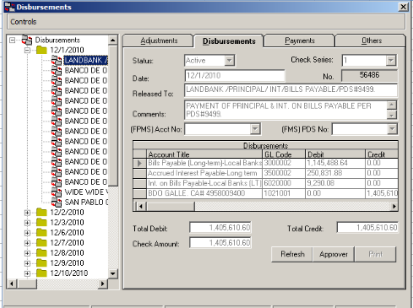

Extracted Data in Excel/Calc Format

      - Payment Module. The following details from FPMS/ AMS report system are the requirements to be extracted.
        - Date, transaction date of the transaction formatted in mm/dd/yyyy, example 12/01/2017
        - Reference No, unique number recognizing as source of information of the transaction.
        - Received From, the client name column formatted in string.
        - Check No, the number of the check used in the transaction.
        - Date Effective, the effectivity date of the transaction.
        - Bank Name
        - Form Of Payment
          - Code
          - Amount
          - Cost Center
        - Application of Payment
          - Code
          - Account No
          - Total
Payment Module
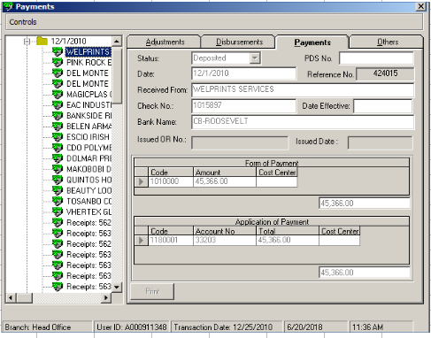

Extracted Data in Excel/Calc Format
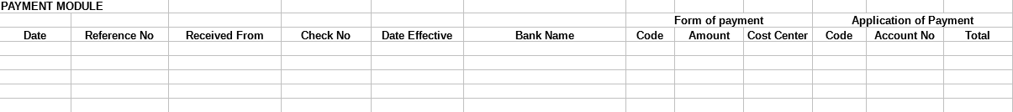

      - Schedule of Subledger. The following details from FPMS/ AMS report system are the requirements to be extracted.
        - Account Name
        - Date with year
        - Particulars
        - Amount. The quantity of money.
Extracted Data in Excel/Calc Format
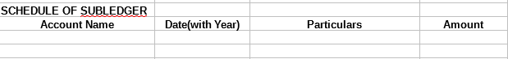

      - Schedule of Check Issuance. The following details from FPMS/ AMS report system are the requirements to be extracted.
        - Check No
        - CV No
        - Payee/Particular
        - Total
        - Extracted Data Format in Excel
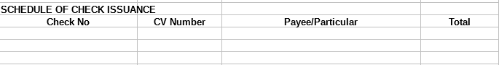

    - BDOLF LPC. The following details from FPMS/ AMS report system are the requirements to be extracted.
      - Account Payment History report
        - Account No
        - Account Name
        - Date Booked
        - First Due Date
        - Collateral
          - Repayment Term
          - Repayment Schedule
          - Original Effectivity Rate
          - Guaranty Deposit
          - Residual Value
        - Report Details
          - Date Paid/Date Issued/Date Effectivity
          - Reference No/OR No
          - Amount Received
          - Period Paid
          - Amount Applied to Loan
          - Amount Applied to Penalties
          - Outstanding Balance
Account Payment History report

        - Extracted Data Format in Excel

      - FPMS Transaction Worksheet report
        - Branch
        - Account Number
        - Client Number
        - Client Name
        - Address
        - Date
        - LAM Number
        - OT Number
        - Review Date
        - Vehicle / Equipment / Real Estate
          - Face Amount
          - Total Loan
          - Proceeds
          - Total UDI
          - Nominal Rate
          - Effective Rate
          - 1st Year Interest
        - Booking Charges
          - Insurance Premium
          - Notarial Fees
          - Doc Stamp
          - Mort Fees
          - Processing Fees
          - Appraisal Fees
          - Commitment Fees
          - OR Number
          - OR Date
          - Net Proceeds
        - Term
        - Amortization
        - Outstanding Balance
        - Remaining Term
        - First Due Date
        - Maturity Date
        - UDI Balance
        - Status
        - Disposition of Proceeds
        - Collateral
        - Available Line
        - Maker
        - Checker
        - RPB
        - AO
FPMS Transaction Worksheet
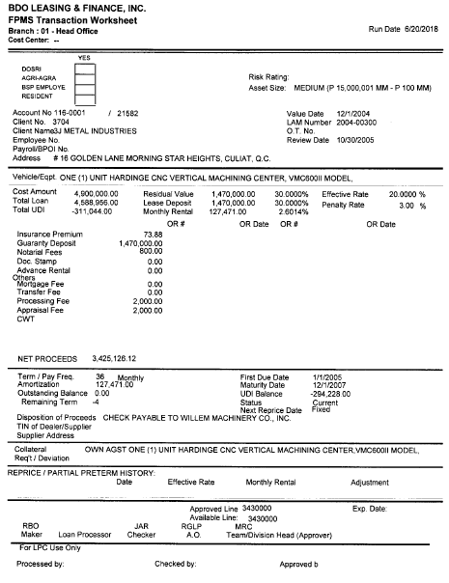

        - Extracted Data Format in Excel

      - Client List of Account report
        - Account Facility No
        - Value Date
        - Maturity Date
        - Total Loan
        - Outstanding Balance
        - Rem Term
        - Installment Amount
        - Net To Close
        - Totals
Client List of Account report

Extracted Data in Excel/Calc Format

Screen Flow
  - Not applicable.

Data Flow Diagram
  - Not Affected by the enhancement.

Performance Levels:
  - Not Affected by the enhancement.

- Security Features
  - Not Affected by the enhancement.

User Roles
  - Reports are accessible only to LPC Loans Processor and LPC Loans Officer only.

Appendices. [please see attached documents]

Appendix A: Project Risk Inventory

Appendix B: Project Work Plan

Appendix C: Project Estimating Worksheet

SIGN-OFF
ITD PROJECT MANAGER  Julius G. Tuazon / Mark Louie E. Cruz / Rod M. Romero  Signature over Printed Name  DATE | BUSINESS UNIT PROJECT MANAGER  Alberto D. Estrella Jr  Signature over Printed Name  DATE
ITD UNIT HEAD  Jonas J. Salonga  Signature over Printed Name  DATE | BUSINESS UNIT HEAD  Juanito C. Lucas  Signature over Printed Name  DATE

